# Mastering Google My Business Optimization

In 2024, local businesses must have a strong online presence. Google My Business (GMB) optimization is key to attracting local customers and improving search visibility. This guide will show you how to optimize GMB for better **local SEO**.

Digital marketing keeps changing, and Google My Business is now vital for small and medium-sized businesses. By learning **GMB optimization**, companies can boost their local search rankings. This attracts more customers and strengthens their online brand.

If you own a restaurant, retail shop, or provide services, knowing Google My Business updates is crucial. It helps you stay ahead in the digital market.

### Key Takeaways

* Learn cutting-edge **GMB optimization** techniques
* Understand the importance of **local SEO** for business growth
* Discover how to improve online visibility effectively
* Maximize your local search potential
* Navigate recent Google My Business platform changes

## Understanding Google My Business: Core Features and Benefits

Google My Business (GMB) is key for local businesses wanting to be seen online. It's a free tool to manage your digital presence on Google Search and Google Maps.

https://www.youtube.com/watch?v=kYX2h29T45w

**Local SEO** has changed a lot with GMB. It gives businesses a chance to reach more people. You can share important info, talk to customers, and get better search rankings.

### Key Components of GMB Profiles

A good Google My Business profile has a few important parts:

* Business name and address
* Contact information
* Operating hours
* Business category
* Photos and visual content
* Customer reviews and ratings

### Why GMB Matters for Local Businesses

The latest **Google My Business update** makes it even more important for local businesses. Now, they can:

1. Get seen more in local searches
2. Share info with customers right away
3. Show they're trustworthy with verified profiles
4. Keep an eye on their online reputation

### Recent Platform Changes and Updates

Google keeps making GMB better for local SEO. They've added features to help businesses shine. These updates make it easier for users and give business owners more tools.

"Google My Business is no longer optional—it's essential for local business success." - Digital Marketing Expert

By using these features, businesses can make a strong online presence. This helps attract and keep customers in today's digital world.

## Setting Up Your Google My Business Profile for Success

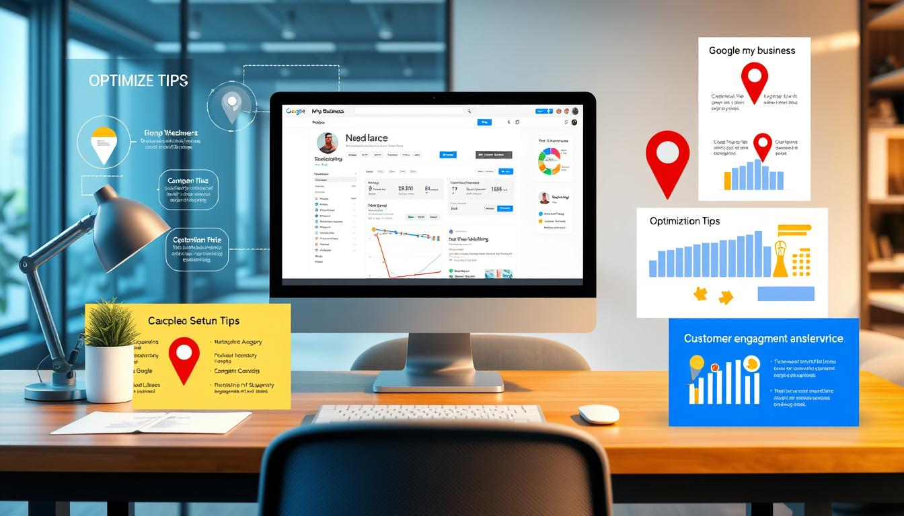Creating a strong Google My Business (GMB) profile is key for local businesses to be seen online. The setup might look hard, but breaking it down helps a lot. This makes **GMB optimization** easier to handle.

First, collect important business info before you start your GMB profile. You'll need:

* Accurate business name
* Complete physical address
* Primary phone number
* Business category
* Operating hours

When picking your business category, be precise. *Choose the most specific category that describes your primary business function*. Google uses this to help people find you in local searches.

"Your GMB profile is often the first impression customers have of your business online." - Digital Marketing Experts

Verification is a key part of GMB optimization. Google has several ways to verify your business, including:

1. Postcard verification
2. Phone verification
3. Email verification

Each method makes sure your business info is real. It also helps stop spam or wrong listings.

Pro tip: Always check your info for accuracy. Having consistent and correct details in your GMB profile boosts your local search rankings.

## GMB optimization, local SEO, Google My Business update: Essential Strategies

Getting the most out of Google My Business (GMB) needs careful planning and action. Local businesses can boost their online presence by using specific strategies. These strategies must match what search engines look for today.

https://www.youtube.com/watch?v=HFT2z3Uj-Q0&pp=ygUNI3Nlb21vZGluYWdhcg%3D%3D

Effective GMB optimization includes key parts that boost local search results:

### Profile Verification Methods

Verifying your GMB profile is the first step to being seen as credible. Google has several ways to verify:

* Postcard verification
* Phone verification
* Instant verification for eligible businesses

### Category and Attribute Selection

Picking the right categories and attributes helps Google get your business right. *Precise categorization boosts local SEO visibility*.

| Category Type | Impact on Local SEO |
| --- | --- |
| Primary Category | Directly influences search results |
| Secondary Categories | Provides additional search context |
| Specific Attributes | Highlights unique business features |

### Service Area Configuration

Setting up your service area helps people know where you are. Businesses can set their area through exact location targeting.

"Accuracy in service area configuration is crucial for attracting local customers and improving search relevance." - Local SEO Expert

By using these GMB optimization strategies, businesses can improve their local search presence. They can also draw in more potential customers with targeted online visibility.

## Optimizing Your Business Description and Services

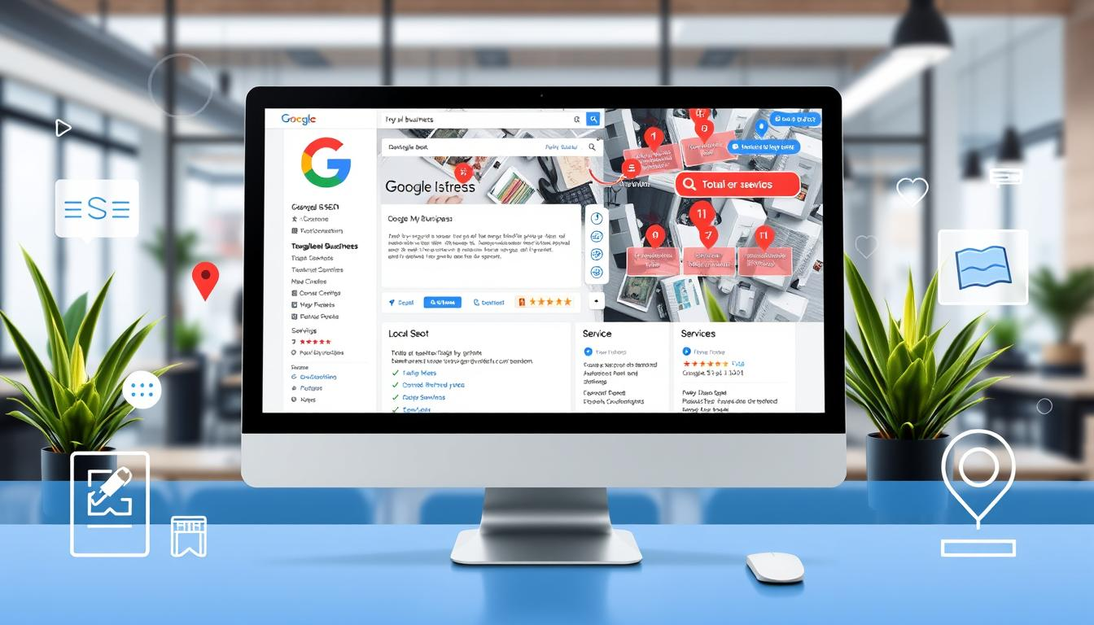Writing a good business description is key for GMB optimization. It's like a digital storefront that shows off what you offer. It should be short, clear, and grab attention to show off your business's best points.

Here are some important things for a great GMB business description:

* Point out your *unique selling points*
* Use industry keywords in a natural way
* Tell what makes your business stand out
* Speak in a lively, engaging tone

"Your Google My Business description is your first chance to share your business story – make it count!" - Local SEO Experts

Being precise with your services is crucial. Break them down into simple categories that people can get. Use specific service names that match what people search for in your field. This boosts your GMB optimization and local search visibility.

Here are some smart ways to list your services:

1. Order your services by importance
2. Be clear about what you offer
3. Share pricing ranges when you can
4. Keep your services up to date

Your GMB profile is a powerful marketing tool. Keep your description and services fresh to stay relevant and attract more customers.

## Mastering GMB Photo and Video Content

Visual content is key for Google My Business (GMB) and local SEO. Your profile's images and videos are the first thing people see. High-quality, real visuals can boost engagement and draw in more local customers.

https://www.youtube.com/watch?v=vSDdAWwn8LU

Creating a strong visual brand is all about strategy. The right mix of professional and casual photos can share your brand's story and services.

### Image Optimization Best Practices

* Upload high-resolution images (minimum 720 pixels wide)
* Include diverse photo types:
  + Exterior storefront shots
  + Interior workspace images
  + Product or service demonstrations
  + Team member photos
* Ensure images are well-lit and professionally edited
* Maintain consistent color scheme and branding

### Video Content Guidelines

Videos are great for GMB optimization. Short, engaging clips can show your business's personality and services better than photos.

* Recommended video length: 30-60 seconds
* Focus on:
  + Customer testimonials
  + Service walkthroughs
  + Behind-the-scenes glimpses
* Use clear audio and professional editing

### Visual Branding Strategies

Consistent visual storytelling builds trust and recognition in local SEO. Your GMB profile should show your brand's unique identity through chosen imagery.

"Great visual content transforms your Google My Business profile from a simple listing to an engaging brand experience." - Digital Marketing Experts

By using these GMB optimization tips, businesses can create a compelling visual story. This story can attract and keep potential customers.

## Managing Customer Reviews and Ratings

Customer reviews are key in local SEO and for your business's online image. Google My Business (GMB) reviews can greatly affect your visibility and customer choices.

"92% of consumers read online reviews and testimonials when considering a local business" - BrightLocal

To manage reviews well, follow these steps:

* Ask happy customers to leave positive feedback
* Reply to every review in a professional way
* Deal with negative feedback in a constructive manner
* Keep up with customer feedback regularly

For local SEO, a proactive review management plan is needed. Businesses should have easy ways to ask for reviews, like:

1. Following up with emails after service
2. Using review request cards
3. Teaching staff how to ask for reviews

Responding to reviews shows you care about your customers. When dealing with negative reviews, focus on:

* Recognizing the customer's experience
* Offering solutions
* Moving conversations offline when needed

| Review Type | Response Strategy | Local SEO Impact |
| --- | --- | --- |
| Positive Review | Thank customer, personalize response | Boosts visibility, builds trust |
| Neutral Review | Ask for specific feedback | Shows responsiveness |
| Negative Review | Apologize, offer resolution | Demonstrates problem-solving |

By using these strategies, businesses can enhance their local SEO and build a strong online reputation. This will attract more potential customers.

## Leveraging GMB Posts for Marketing Impact

Google My Business (GMB) posts are a great way for local businesses to connect with customers online. They let you share updates, deals, and important info easily. This makes it simple to keep your online profile fresh and engaging.

Understanding the different types of GMB posts can boost your marketing. Each type has its own role in reaching out to customers and keeping them interested.

### Post Types and Their Uses

* *Offer Posts*: Highlight special discounts or promotions
* *Event Posts*: Promote upcoming business activities or special gatherings
* *Product Posts*: Showcase new or featured products
* *Update Posts*: Share recent business news or changes

### Content Calendar Planning

Planning your content helps keep your GMB updates regular. A good content calendar keeps you in touch with your audience all the time.

| Content Type | Frequency | Purpose |
| --- | --- | --- |
| Promotions | Weekly | Drive sales and attract customers |
| Events | Monthly | Increase community engagement |
| Product Updates | Quarterly | Highlight new offerings |

### Measuring Post Performance

The **Google My Business update** offers detailed analytics for post performance. You can see views, clicks, and interactions to improve your marketing.

"Effective GMB posts transform your online profile from a static listing to an interactive marketing platform." - Local SEO Expert

By using these strategies, businesses can make the most of GMB. They can build strong connections with potential customers through engaging content.

## Understanding GMB Insights and Analytics

Google My Business (GMB) insights give you powerful data to change your local marketing. These analytics show how customers interact with your business online. They reveal important info about user engagement and search performance.

Key metrics in GMB optimization help businesses see their digital visibility:

* Search queries that trigger your listing
* Customer actions like website clicks and phone calls
* Photo view counts and engagement rates
* Customer direction requests

*Tracking these insights allows businesses to refine their local SEO approach and understand customer behavior patterns.*

"Data is the new oil of the digital marketing landscape" - Local SEO Experts

GMB optimization relies on interpreting these analytics strategically. Businesses can identify:

1. Peak search times for their business
2. Most popular customer interaction methods
3. Geographic reach of search visibility
4. Performance compared to local competitors

By regularly reviewing GMB insights, local businesses can make data-driven decisions. This enhances their online presence and attracts more potential customers.

## Advanced Local SEO Integration Techniques

To boost your local SEO, you need more than just basic steps. Successful local businesses know how to connect different digital marketing channels. This helps increase their online visibility.

Digital marketing experts see local SEO as a big system. It's made up of many strategies working together to improve your online presence.

### Local Keywords Implementation

Creating a strong local keyword strategy is more than just using location-based terms. Here are some advanced techniques:

* Find search terms that are specific to your area
* Use long-tail keywords that match what local customers search for
* Make content that naturally includes local phrases

### Citation Building Strategies

Building strong local citations needs careful planning. Focus on these:

1. Find top local business directories
2. Make sure your NAP (Name, Address, Phone) info is the same everywhere
3. Keep an eye on and update your citation profiles often

### Cross-Platform Optimization

Good GMB optimization goes beyond one platform. Make sure your digital presence is unified by:

* Keeping your info the same on social media
* Creating content that fits each platform
* Tracking how well your content does on different platforms

"Local SEO is not about being found everywhere, but being found in the right places with the right message." - Digital Marketing Expert

By using these advanced local SEO techniques, businesses can build a strong digital marketing strategy. This strategy drives real local engagement.

## Common GMB Optimization Mistakes to Avoid

Google My Business (GMB) optimization needs careful attention. Many local businesses unknowingly harm their online presence. They make mistakes that affect their digital visibility.

Understanding GMB optimization is key. It requires strategic thinking and knowing common pitfalls. Let's look at the top mistakes that can hurt your local search ranking.

* Inconsistent Business Information Across Platforms
* Neglecting Regular Profile Updates
* Ignoring Customer Reviews
* Incomplete or Inaccurate Business Categories

"The smallest details can make the biggest difference in Google My Business optimization." - Digital Marketing Experts

Optimizing GMB needs a proactive approach. Businesses often overlook the importance of keeping info up-to-date. *Outdated contact details, wrong service areas, or misaligned descriptions can hurt your local search visibility*.

| Mistake | Impact | Solution |
| --- | --- | --- |
| Inconsistent NAP Details | Reduced Search Ranking | Audit and Synchronize Information |
| Missing Business Hours | Lower User Trust | Update Regularly |
| No Profile Photos | Decreased Engagement | Add High-Quality Visual Content |

The latest **Google My Business update** highlights the need for dynamic profiles. Businesses must keep their listings up-to-date, engage with customers, and use new features. This helps them stay ahead in local search results.

* Conduct monthly profile audits
* Respond to all customer reviews
* Update business information promptly
* Utilize all available GMB features

By avoiding these common mistakes, local businesses can boost their online presence. They can attract more customers with smart digital marketing strategies.

## Conclusion

Google My Business optimization is key for local businesses to be seen online. By using the strategies in this guide, they can boost their local SEO. This helps them attract more customers through online searches.

The world of GMB optimization keeps changing, thanks to Google's updates. Businesses must keep up by actively using these platforms. They need to pick the right categories, manage their visuals, and watch customer feedback.

Small businesses and local entrepreneurs can improve their online image with GMB optimization. They can write great descriptions, post smartly, and manage reviews well. Each step helps build a strong online presence that local customers will notice.

Local SEO is a continuous effort to get better and adapt. By staying informed and using the best practices, businesses can build a strong online strategy. This strategy helps them engage with customers and grow in a competitive online world.

## FAQ

### What is Google My Business (GMB) and why is it important for local businesses?

Google My Business is a free tool for managing your online presence. It helps you control how you appear on Google Search and Maps. It's key for local SEO, letting you share accurate info and talk to potential customers directly.

### How often should I update my Google My Business profile?

Update your GMB profile at least once a month. Refresh photos, update hours, add new services, and respond to reviews. Also, create posts to keep your profile lively and engaging.

### What are the most important elements to optimize in a GMB profile?

Focus on accurate business details like name, address, and phone number. Also, include a detailed description, relevant categories, and high-quality photos. Make sure your hours are up-to-date and your service areas are clear. Consistent customer reviews are also vital.

### How do I verify my Google My Business listing?

Google offers several ways to verify your listing. The most common is getting a postcard with a code at your business. Then, enter the code in your GMB account.

### Can I optimize my GMB profile for multiple locations?

Yes, you can manage multiple locations with one Google account. Each location needs its own verified listing with unique, accurate info.

### How do customer reviews impact my GMB optimization?

Reviews are key for local SEO. They show social proof, boost visibility, and tell Google your business is trusted. Reply to all reviews to improve your local search ranking.

### What types of posts can I create on Google My Business?

GMB lets you post updates, offers, events, and products. These posts engage customers, showcase your latest, and share timely info about your business.

### How can I improve my GMB profile's visibility in local search results?

To boost visibility, ensure your profile is complete and accurate. Regularly update your listing, add quality photos, and collect positive reviews. Use relevant keywords and post regularly.

### What are the most common mistakes to avoid in GMB optimization?

Avoid using wrong categories, having inconsistent NAP info, and not responding to reviews. Don't forget to add photos and use GMB insights to improve your strategy.

### How do GMB insights help my local marketing strategy?

GMB Insights offer data on how customers find and interact with your listing. This info helps you understand your audience and refine your marketing.